Appendix A - Project Specification

Computing and Multimedia Postgraduate Programme

MSc in Internet Systems Development

Project Specification

Nikolaos Fountas

- Basic details

Student name: | Nikolaos Fountas
Draft project title: | PUMS/SUMS project monitoring sub-system
Course and year: | MSc Internet Systems Development, 2007
Client organisation: | University of Portsmouth
Client contact name: | Jim Briggs

- Outline of the Project Environment
The University of Portsmouth’s School of Computing currently uses an online system called the Project Unit Management System (PUMS) to allow undergraduate students or external parties to submit their ideas for their final year project. In addition PUMS has more features such as Project Allocation which allows supervisor allocation to students and project monitoring.

- The problem to be solved
PUMS needs to be redesigned and re implemented in order to provide more functionality to the users and also to improve the existing subsystems. The new system that is being developed which is called SUMS is logically divided in five sub-systems as the following: 1) Project Ideas, 2) Project Submission, 3) Project Allocation, 4) Project Monitoring 5) Student Feedback. The project monitoring system will be used to monitor students' progress with their project

The aims and objectives of this project is to redesign and re implement the Project Monitoring Subsystem by adding the following features: ability of the project co-ordinator to set milestones for all students; supervisors and students able to set individual milestones; recording of progress reports; recording of milestones met/not-met (including in bulk); calculation of penalties associated with missed milestones.

In addition one of the major problems of PUMS is that the existing system was implemented in a non MVC style. The non-MVC pattern makes the process of maintaining the existing code much harder than using an MVC pattern, because the presentation logic is mixed with the business logic.
This alternative approach will be developed using new technologies in Java software development area, which allow the code to be more maintainable and easier to read.

- Breakdown of tasks
- Requirements Elicitation
This step includes discovering the actual requirements of the system. For this, information about the existing Project Monitoring system of PUMS has to be obtained, by interviewing the Project Coordinators in the School of Computing Department of the University of Portsmouth and studying the existing system.

- Requirements Analysis
This step will include the writing of the requirements from the elicitation process into a more formal way. At this stage, diagrams showing the operations of the system will be produced including: User Interaction, System Architecture and Entity-Relationship Diagrams.
- Design & Implementation
At the same time the implementation of the system can start. First the design of the web interface will take place, and after that the actual implementation (coding) can be started. The system will be implemented using Struts version 2.0.6 and Hibernate 3. Also AJAX features may be used.
- Testing & Evaluation
The system in addition of the excessive testing that would take place during the implementation, it will be tested as a whole after the implementation finishes using the White Box and Black Box methods.
Then the system will be evaluated against the client’s requirements. In case it does not meet all of them appropriate modifications will be done.

- Project Deliverables
The Project Deliverables to be produced will be the Project Monitoring application, Java Documentation, and User Documentation if required.

- Requirements
The requirements of this project will be obtained by examining the existing system (PUMS), talking to relevant people that is people who have used the PUMS project milestones monitoring subsystem in the past. In addition, the author will interview people who currently use it in order to discover potential weaknesses, and by looking at other Project Management systems such as MS Project or systems installed at other Universities.

- Legal, Ethical, Professional Issues
The system to be developed must ensure that individual milestones should be pointed to exactly one student. No ethical or social issues are involved with this type of project.

- Facilities and resources
The available facilities and resources include the University’s computing facilities; the University’s Frewen Library to obtain books related to Java programming; Personal Computing facilities where the system will mainly be developed, and books related to the Hibernate 3 and Struts 2 frameworks. Any books not available in the Library will have to be purchased from various sellers. Last, it is expected that online documents will be of use during the implementation stage.

- Project plan

- Briefly, some of the Project tasks would be:

- Study Project Monitoring Processes
- Study Struts 2 Framework

- Requirements Elicitation
  - Elicit Requirements from relevant people or other PM systems.
- Requirements Analysis
  - Define Site Requirements
  - Define Site Characteristics
  - Produce Diagrams
- Design
  - Design Web Interface
- Implementation
  - Implement Web Interface
  - Coding
- Testing
  - Black Box testing
  - White Box testing
- Evaluation
- Write Up Project's Report
- Presentation
- Finalise Report
- Submit Project

- Project mode
 | Please delete as appropriate
Registration mode | Full Time | Part Time
Project mode | Full Time | Part Time
Planned submission deadline | September 2007

- Signatures
 | Signature: | Date:
Student
Client
Project supervisor

Appendix B - Use Case Diagrams and Descriptions

For Administrator and Unit Coordinator

Use Case #1

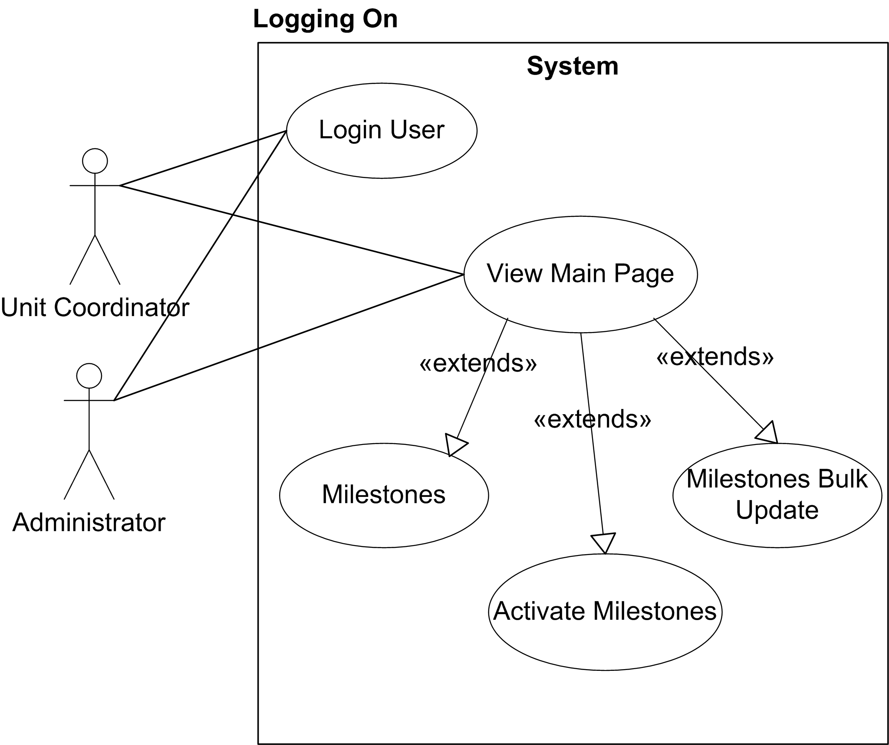

Use Cases Description:
Login User
Everyone can view the login page, which is the start page of the application.
The Login page contains three Login sections: Unit Coordinator, Supervisor and Student sections. If login successful the Main Page is shown else return user to login page.
View Main Page
A general page to welcome a user. It is the first page the application displays after a successful login.
This page will contain a top navigation bar with three drop down menus
The first menu selects the Cohort, the second selects Units and the third one, one of following pages: Milestones, Activate Milestones, Milestones Bulk Update
Logoff
Clicking Log off on the Main Page will return the user to the home page

Use Case #2

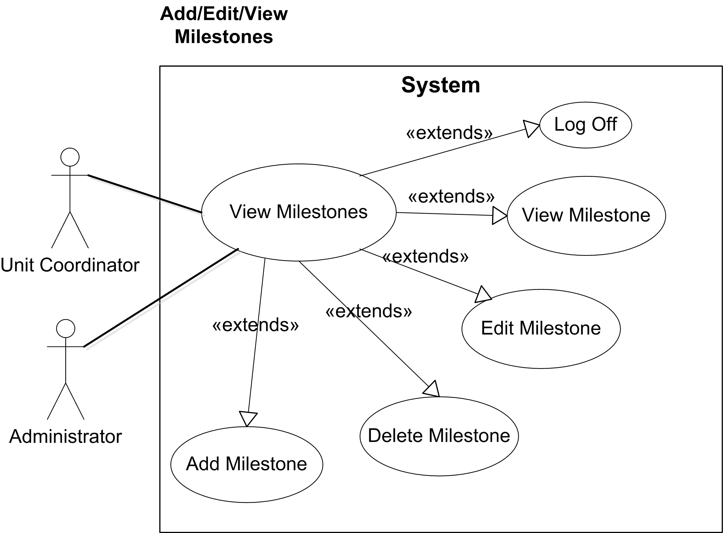

Use Cases Description:
View Milestones:
This is the page where a list of milestones will be displayed to the user. Information to be displayed for milestones are:
- Start Date: The date becomes live
- End Date: Date milestone becomes overdue
- Description: description of milestone (can be considered as name as well)
- Status: Active or not Active
- Buttons: Edit, View. Delete

Also an HTML link will be displayed on the top of the page.
Clicking on the link will display a page the add milestone page.
Add Milestones:
The Add Milestone page will have the following fields:

- The date becomes live
- Date milestone becomes overdue
- Description
- Units applied to
- Lowest Role allowed to update this
- File Attachment Type
- Max File Attachment

An update button will be at the bottom of the page. Clicking the Save button the application will save the milestone to the database.
Edit Milestone:
Clicking on the Edit Button will display the Add Milestone page but with the fields filled with the values from the selected milestone (fetched from the database).

Clicking the Save button the application will save the milestone to the database.
View Milestone:
Clicking on the View Button will display the Add Milestone page but with the fields filled with the values from the selected milestone (fetched from the database) READ-ONLY!

Clicking on the Delete Button will pop up a dialog box, asking the user to confirm the deletion of the milestone
Logoff
Same as in Use Case #1

Use Case #3

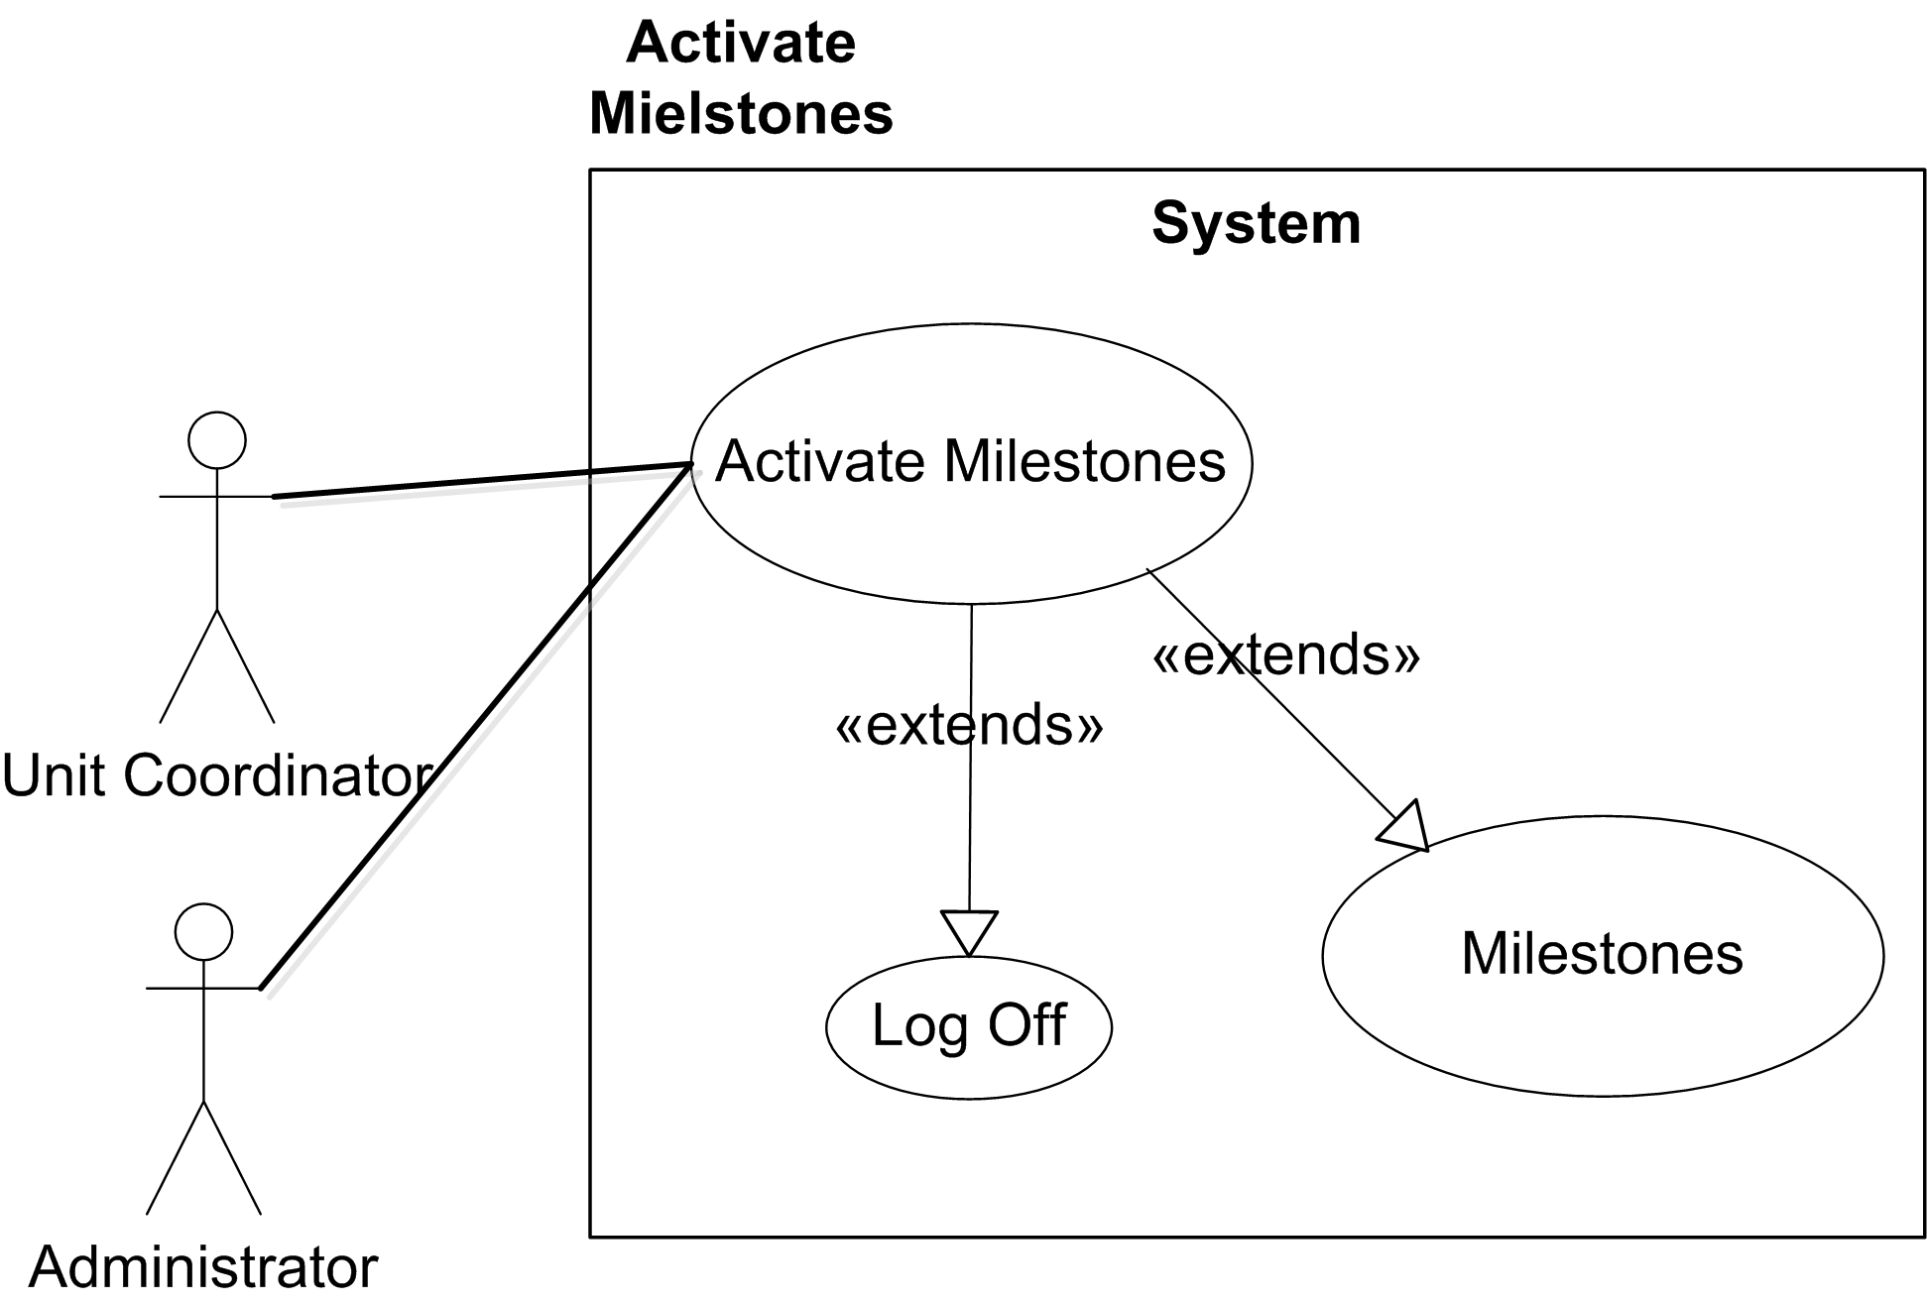

Use Cases:
Activate Milestones
This page is displayed when the Activate Milestones option is selected from the drop down menu.

This page will contain two lists of Milestones to be activated or deactivated.
Each milestone on the list contains information as defined in Use Case #2, Use Case: Milestones and in addition a checkbox on its right. Checkboxes are used for bulk update of milestones.

Update buttons will at the bottom of each list. Clicking the buttons will change the status of selected milestones accordingly.
Logoff
Clicking Log off on the Main Page will return the user to the home page

Use Case #4

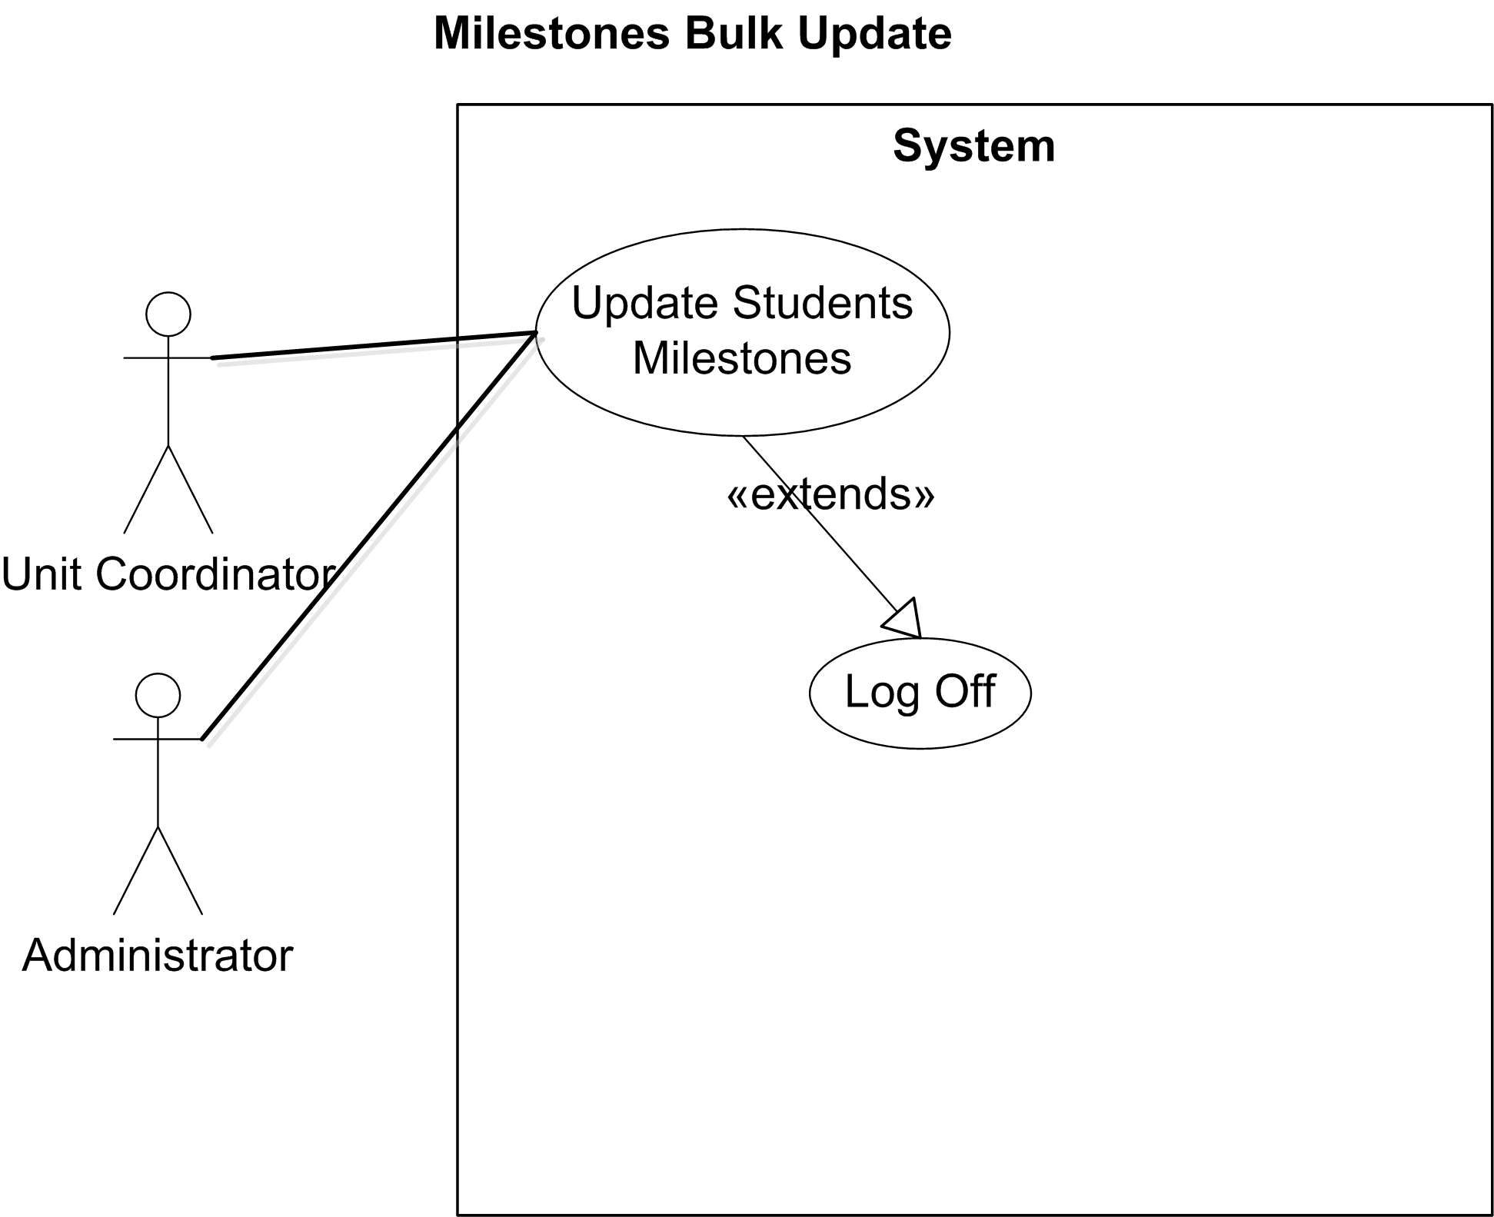

Use Cases:
Update Student Milestones
This page is displayed when the Milestones Bulk Update option is selected from the drop down menu.

This page will display a list of Student Milestones where a Unit Coordinator or an administrator can select through checkboxes the student milestones to update .Each milestone on the list contains information as defined in Use Case #2, Use Case: “Milestones” Checkboxes are used for bulk update of
An update button will be at the bottom of the list. Clicking the buttons will change the status of selected milestones accordingly and save the changes to the database.
Logoff
Clicking Log off on the Main Page will return the user to the home page

For Supervisors

Use Case #1
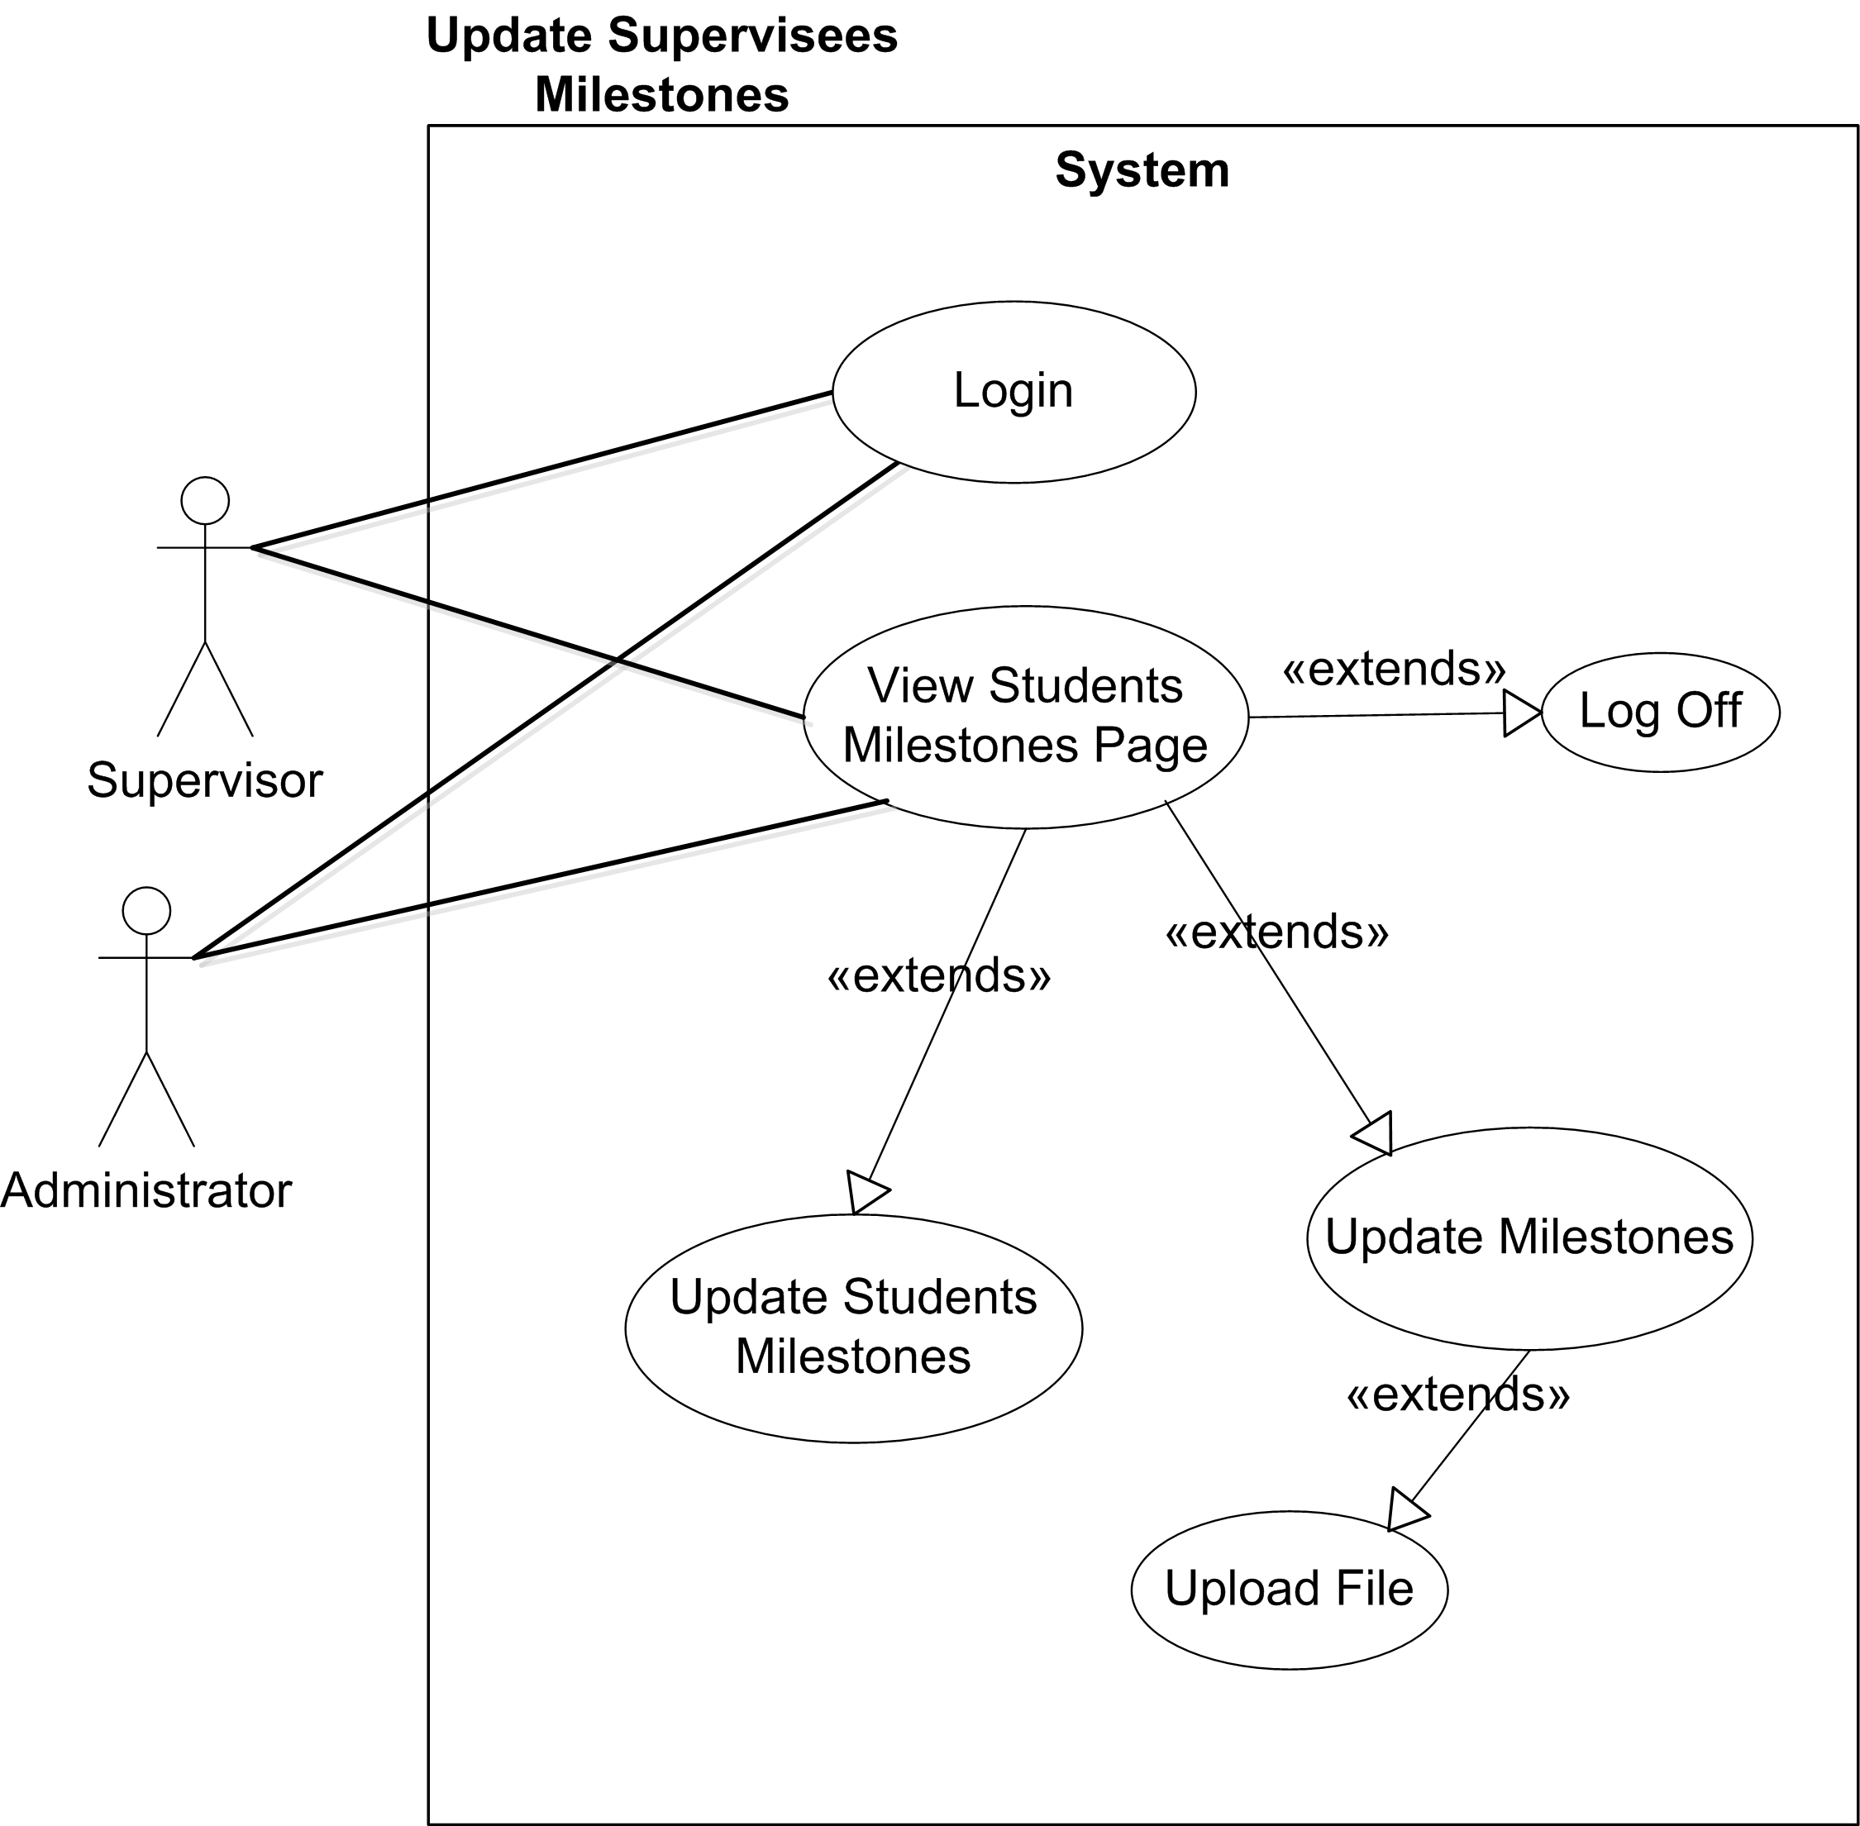

Use Cases Description:
View Student Milestones
This is the page displayed after a user Login.

The View student milestones page is broken down into 2 components.
- Milestones
- Supervisees

The milestones component shows a list of the Active Milestones and the Supervisees component a list of supervisees.

Each “Milestone” row shows the same information as in Use Case #2, Use Case: “Milestones”.
In the Milestones component, a checkbox is displayed so that supervisors can select multiple milestones to update. Same for the supervisees.

Each “Supervisee” row shows the following information.
- Student’s Hemis Number
- Student’s First Name
- Student’s Last Name
- Student’s Project Title
- Student’s Project Status

At the bottom of each component there are buttons that clicking them will show the View Final Projects Page (for the Milestones List) and the View Milestones for the Supervisees page.
Update Student Milestones
Clicking the Display button in the Milestones component displays the View Final Projects Page.

This page shows a list of Final Projects according to the number of milestones selected in the Milestones component of the View Students Milestone page.

For example, if two milestones have been selected, this page shows two lists one for each milestone, of supervisees’ milestones. Each of the rows in the list will show information of the supervisee’ as defined in the View Milestones Page but also a drop down menu with the following options:

- “Completed”
- “Not reported/Uncompleted”
- “Unreported”

Next to the drop down menu there will be an Upload facility.
This facility includes a button where the Dialog box is displayed when clicked.
A textbox to display the filename of the selected file.

Clicking the update button the values of the selected option of the drop down menu will be saved in the database.
Update Milestones
The View Milestones page is displayed by selecting supervisees from the Final Projects Component.

This page will display a list of Active Milestones for the selected Final Projects.
Each of the rows in the list will show information of the Supervisees milestones as defined in the View Milestones Page but also a drop down menu with the following options:

- “Completed”
- “Not reported/Uncompleted”
- “Unreported”

Next to the drop down menu there will be an Upload facility.
This facility includes a button where the Dialog box is displayed when clicked.
A textbox to display the filename of the selected file.

*** Supervisors can select to upload a file for multiple students (Bulk Uploading) ***

At the end the second list an Update button is displayed.

Clicking the update button the values of the selected option of the drop down menu will be saved in the database.

For Students

Use Case #1

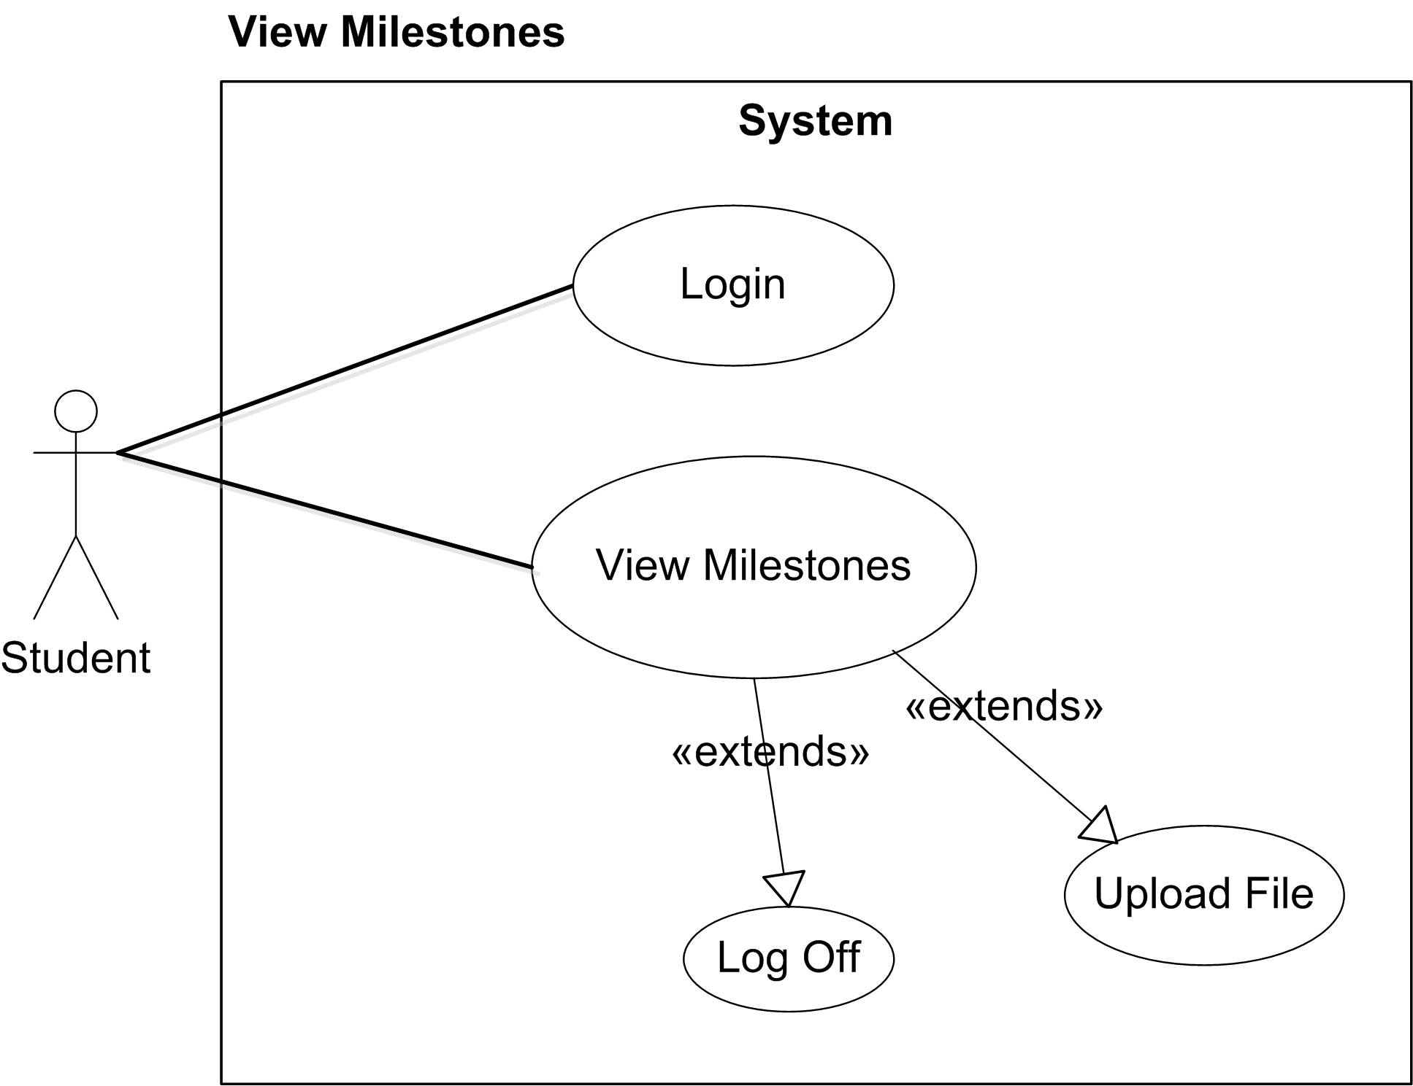

Use Cases Description:
View Milestones
This page is displayed after the user has successfully logged in to the Student Section.

This page will display a list of Student Milestones. Each milestone on the list will display the following information:

- Start Date
- End Date
- Milestone Description
- Status
Also some milestones may be associated with uploading a file.

Next to the drop down menu, there will be an Upload facility.
This facility includes a button where the Dialog box is displayed when clicked.
A textbox to display the filename of the selected file.

User can upload a file ONLY three times until the Supervisor responds with comments/new file.

Login
A user can login to the system by providing its login details.
If the login details are wrong an error message should be displayed to the user
In the login page. If the login details are correct the View Milestones page is displayed.

Appendix C - The Database Design

M = Mandatory, O = Optional

- The “milestones” Table

The “milestones” table needed to represent all the data for Milestones that would be set up by the Unit Coordinator (see Section 3, 2. “Setting up milestones for each Cohort”)

Milestones | Requirement
MILESTONE_ID [PK]
START_DATE | M
END_DATE | O
STATUS | O
DESCRIPTION | M
DATE_ADDED | O
LAST_EDITED | M
PERSON_ID [FK] to person table | M
ROLE_ID [FK] to role table | O
ATTACHMENT_TYPE_ID [FK] to file_attachment_types table | O

Relationships:

Column: PERSON_ID has a ‘many-to-one’ relationship with column PERSON_ID of the Person table.

Column: ROLE_ID has a ‘many-to-one’ relationship with column ROLE_ID of the Roles table.

Column: ATTACHMENT_TYPE_ID has a ‘one-to-one’ relationship with column ATTACHMENT_TYPE_ID of the File_Attachment_Types table.

- The “munitmilestones” Table

The “munitmilestones” table created considering the fact that there would be some milestones associated with more than one Unit. On the initial designing of the database tables, this requirement was implemented as a separate column (“UNIT”) in the “milestones” table but later it was realized that having that column in the “milestones” table might lead to inconsistencies or in additional programming effort when interacting with a milestone.

For example, suppose that for a particular milestone three units applied to so three rows would have to be created in the milestones tables for that milestone. However, any modification to it, such as a change to the milestone description would result on having to update three rows rather than one. The same would occur for deletion and insertion.

Also, logical inconsistencies may occur especially in an update operation.
For instance, there may be a query in the model of the Application where it needs to retrieve a milestone by a specific Unit and update that milestone. In this case, a single row would be returned, modifications will occur and will be saved for only this specific milestone, which happens to be the same milestone for the other three rows as well. So, if later on the application needs to retrieve a milestone by its description wrong results will be displayed.

Considering the above facts, it was decided to separate Milestones, Units and Cohort and create a new table named “munitmilestones”.

The “COHORT_ID” was also added to the “munitmilestones” to avoid creating a new table (e.g. mcohortmilestones) which would look like a duplicate of this one.

Munitmilestones | Requirement
UNITMSTNID [PK] | M
MILESTONE_ID [FK] to milestones table | M
UNIT_ID [FK] to Unit table | O
COHORT_ID [FK] to Cohort table | O

Relationships:

Column: MILESTONE_ID has a ‘many-to-one’ relationship with column MILESTONE_ID of the milestones table.

Column: UNIT_ID has a ‘many-to-one’ relationship with column UNIT_ID of the Unit table.

Column: COHORT_ID has a ‘many-to-one’ relationship with column COHORT_ID of the Unit table.

- The “mstudentmilestones” Table

To store the students’ milestones a table needed. Student Milestones are the milestones associated with each student and its main purpose is to keep the status (“Completed”, “Unreported”, “Not Completed” etc.) of each milestone of a student. Without this table, there would be no way for a Supervisor to update the status of the milestones corresponding to their supervisees or the Unit Coordinator to update in bulk individual student milestones.

mstudentmilestones | Requirement
STUDMSTNID[PK] | M
STATUS
PENALTY | O
STUDENT_ID [FK] to Student table | O
PROJECT_ID [FK] to Final_Project table | M
MILESTONE_ID [FK] to milestones table | O
DATE_ADDED | M
LAST_EDITED | M
STAFF_NO [FK] to Staff table | O
FILE_ATTACHMENT _ID [FK] to file_attachment table | O

Relationships:

Column: STATUS has a ‘one-to-one’ relationship with column STATUS of the Statuses table.

Column: STUDENT_ID has a ‘one-to-one’ relationship with column PERSON_ID of the Person table.

Column: PROJECT_ID has a ‘many-to-one’ relationship with column PROJECT_ID of the Final_Project table.

Column: MILESTONE_ID has a ‘many-to-one’ relationship with column MILESTONE_ID of the milestones table.

Column: STAFF_NO has a ‘many-to-one’ relationship with column STAFF_NO of the Staff table.

Column: MILESTONE_ID has a ‘many-to-one’ relationship with column MILESTONE_ID of the milestones table.

Column: FILE_ATTACHMENT_ID has a ‘one-to-one’ relationship with column FILE_ATTACHMENT_ID of the File_Attachment table.

The “fileattachment” Table

The “fileAttachment”, as its name indicates is the table where all the file attachments associated with a student milestone will be stored.

It should be noted that this table was designed as a generic table where any file attachments can be stored in it not only those associated with a student milestone. For example, the Unit Coordinator may desire to associate a file attachment on with an e-mail message that might send to Supervisors to remind them to change the status of their supervisees’ milestones. This is the place where that file attachment may be stored.

fileAttachment | Requirement
FILE_ATTACHMENT_ID [PK] | M
ATTACHED_FILE | M
FILE_NAME | O
FILE_SIZE | O
CONTENT_TYPE | O
STATUS | O
LAST_EDITED | O
ATTACHMENT_TYPE_ID [FK] to File_Attachment_Types table | O
TIMES_LEFT | O
IP_ADDRESS | O

Relationships:

Column: ATTACHMENT_TYPE_ID has a ‘one-to-one’ relationship with column ATTACHMENT_TYPE_ID of the File_Attachment_Types table.

- The “fileAttachmentTypes” Table

This table stores the file attachment types.

A file attachment type in the new subsystem will not be related with the content type or the extension of the file to be uploaded such as .DOC, .PDF, or zip file etc. A file attachment type here correlates with the name of the milestone that needs to be associated with a file. For example, the milestone “Progress Report” will be associated with a type of “Progress Report” or the “Submit Final Project” milestone will be associated with the “Final Project” type.

Munitmilestones | Requirement
ATTACHMENT_TYPE_ID [PK] | M
DESCRIPTION | M
ALLOWED_SIZE | O

Appendix D - Requirements Specification

Project Milestones Monitoring System
University of Portsmouth Project

Project Author: Nikolaos Fountas
Project Supervisor: Dr. Jim Briggs

Requirements Specification
Version: 1.2
Last Update: 22 July 2007

This is a requirements specification document for the Project Milestones Monitoring System. It contains both the technical and non-technical requirements for the final software application. Additions/alterations during the software’s development are highly likely to be made to the specification. If any changes occur, this document will be amended.

Contents:

A. Revision of Changes
B. System Requirements

A. Revision of Changes

Version Revision | Date of Change | Amendment | By Whom
1.1 | 17/07/2007 | Added  Requirements, 2.1.2 and 2.1.3 | Author
1.2 | 22/07/2007 | Added  Requirements, 3.2.1, 3.2.2 | Author

B. System Requirements

The following are requirements of the new Project Milestones Monitoring System. They are categorised by the groups of people that will be using the system.

- Unit-Coordinator/Cohort-Coordinator/Administrator

The system should allow users to:
  - set milestones for all students
  - set individual milestones
  - associate a file attachment with milestone(s)
  - view a report for milestones of students belonging to a specific Cohort
  - allow users to add, edit, and delete milestones
  - recording of milestones met/not-met (including in bulk)
  - associate penalties with milestones
  - calculation of penalties associated with missed milestones of students

- Supervisors/Administrator

The system should allow users to:

  - View/Update status of milestones of their supervisees including in bulk.
    - Undo an update
    - Bulk Update of milestones for each supervisee
    - Bulk Update of milestones associated with a supervisee
  - Download File Attachments, uploaded by their supervisees
  - Respond to a File Attachment, by either uploading a new file or by writing comments in a web page that can be accessed by a supervisee. Only supervisors and their supervisees should have access to that page.
  - Decide whether a penalty should be applied or not
  - Specify reason if penalty should not apply.

- Students/Administrator

The system should allow users to:

  - View a report of milestones associated to them.
  - Upload File Attachments to particular milestones
    - If milestone is overdue, no file upload is allowed
    - If milestone is not overdue, but reported as “Not completed”, no file uploaded is allowed.
  - Upload a File Attachment again
    - Upload a file three times within a session.
    - Upload a file three times within a session or in general until the Supervisor responds.
  - Download file uploaded by Supervisor
  - Access comments

Milestone:
To set up a milestone a user should provide the following information:

- The date in which the milestone becomes live,
- The date, which the milestone becomes inactive.
- The Units that this milestone applies to.
- Milestone Description.
- Lowest role to update the Milestone.
- File Attachment Type. (Optional)
- Maximum size of Attachment. (Optional)

Appendix E - Initial Project Plan

Appendix F - Final Project Plan

Appendix G - Code Listing

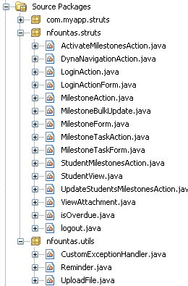

This Appendix contains the most important classes of the web application. Due to the large number of classes the application has and the already large number of the pages of this report, it was decided not to include all of them. However, all the components of the application can be found on the CD attached with this dissertation.

The classes, available in this report are:
- DynaNavigation
- MilestoneBulkUpdate
- StudentMilestonesAction
- View Attachment

JSP Pages:

